Lab 3
https://github.com/EvanBrown-Git/Essentials
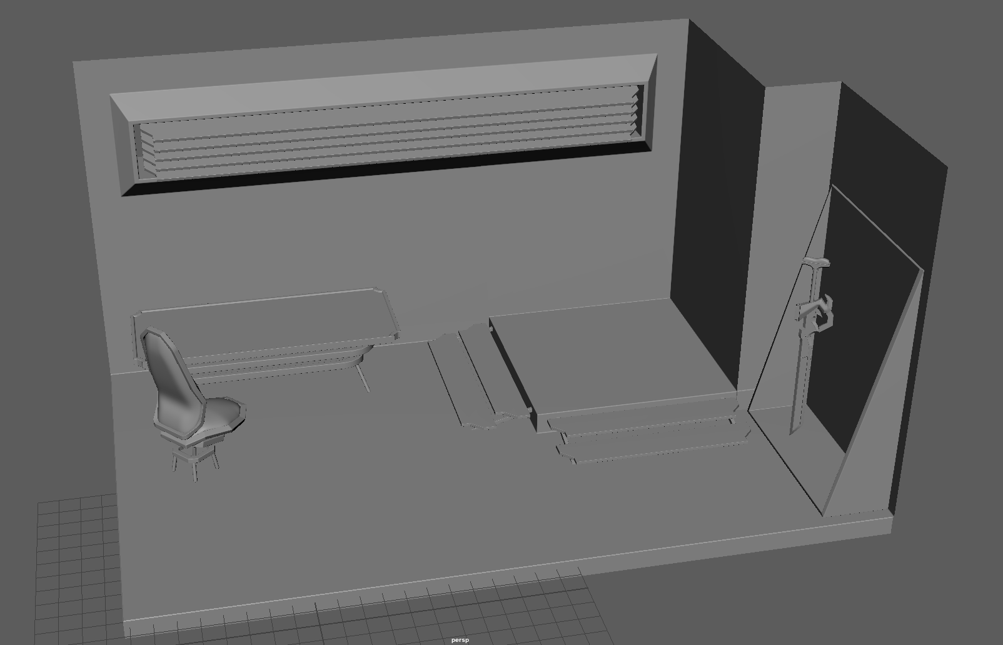
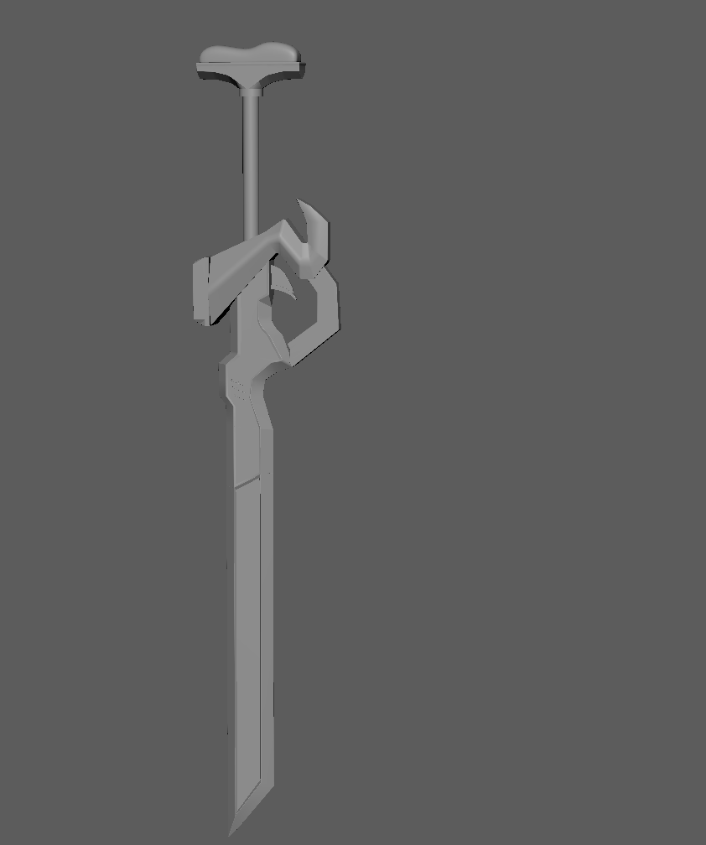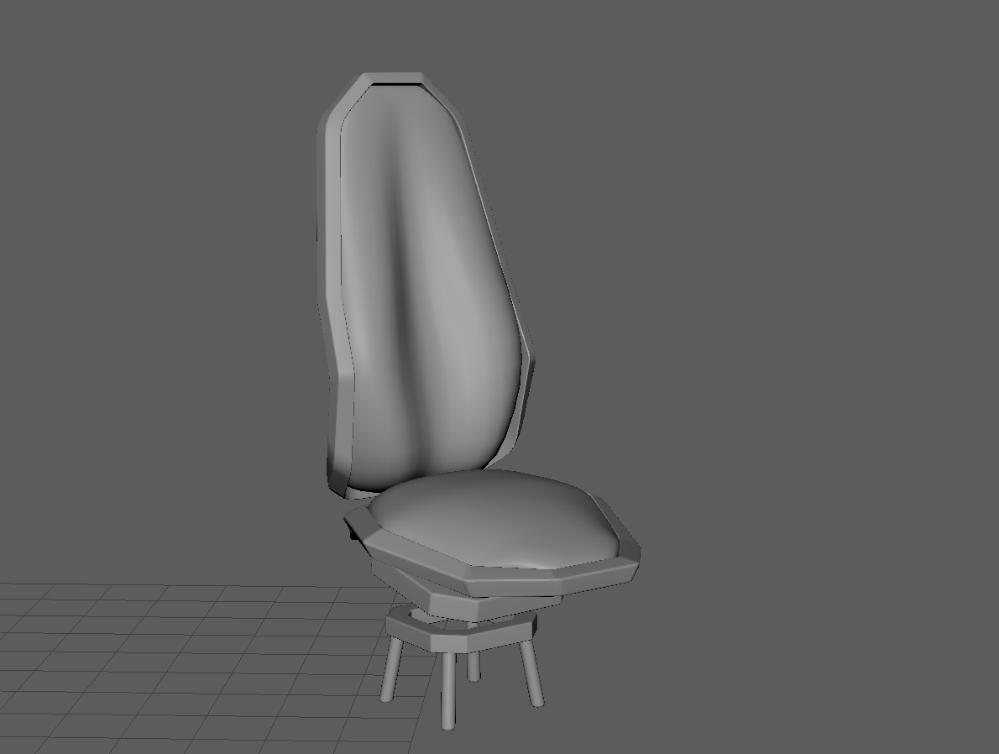
The floor and walls were made by modifying a cube with the extrude and bevel modifiers. The chair frame was made by modifying cubes with the extrude, bevel, bridge, and edge loop modifiers. The chair cushions were made by modifying cubes with the edge loop and smooth modifiers. The stairs were made with the edge loop/multicut (I use them interchangeably so wherever you see a mention to edge loops here just know that it could also be the multicut tool) and bevel modifiers. The table was made by modifying cubes with the edge loop, bevel, extrude, and bridge modifiers. The legs for both the table and chair legs were simply manipulated cylinders that were beveled. The vent was made by manipulating a cube with bevel and edge loop, then duplicating it. The rack frame (bottom right corner) was made by manipulating a cube with extrude, bridge, bevel, and edge loop. The sword was made by drawing a reference and manipulating shapes with all the tools I’ve mentioned so far plus the delete edge and target weld modifiers.

P.S. sorry about forgetting to make a lab 2 write up, I’ll do my best not to miss any in the future.

